PIZZA SALES SQL QUERIES
A. KPI’s
1. Total Revenue
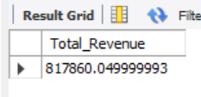
SELECT SUM (total_price) AS Total_Revenue FROM pizza_sales;

2. Average Order Value
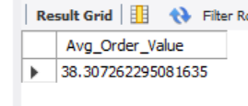
SELECT SUM(total_price) / COUNT(DISTINCT order_id) AS Avg_Order_Value FROM pizza_sales;

3. Total Pizza Sold
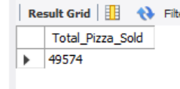
SELECT SUM(quantity) AS Total_Pizza_Sold FROM pizza_sales;

4. Total Orders
SELECT COUNT (DISTINCT order_id) AS Total_Orders FROM pizza_sales;
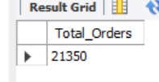

5. Average Pizzas Per Order
SELECT CAST(CAST(SUM(quantity) AS DECIMAL(10,2)) /
CAST(COUNT(DISTINCT order_id) AS DECIMAL(10,2)) AS DECIMAL(10,2))
AS Avg_Pizzas_per_order FROM pizza_sales;
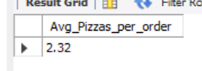

B. Daily Trend for Total Orders
SELECT DAYNAME(order_date) AS order_day, COUNT(DISTINCT order_id) AS total_orders
FROM pizza_sales
GROUP BY DAYOFWEEK(order_date), DAYNAME(order_date)
ORDER BY DAYOFWEEK(order_date);

Output:
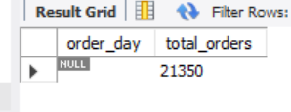

C. Hourly Trend for Orders
SELECT HOUR(order_time) AS order_hours, COUNT(DISTINCT order_id) AS total_orders
FROM pizza_sales
GROUP BY HOUR(order_time)
ORDER BY HOUR(order_time);

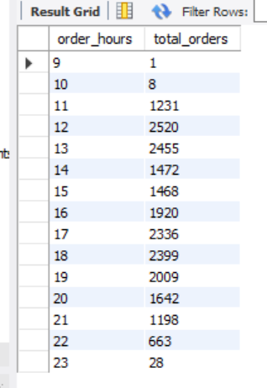
Output:

D. % of Sales by Pizza Category
SELECT pizza_category, CAST(SUM(total_price) AS DECIMAL(10,2)) as total_revenue,
CAST(SUM(total_price) * 100 / (SELECT SUM(total_price) from pizza_sales) AS DECIMAL(10,2)) AS PCT
FROM pizza_sales
GROUP BY pizza_category;

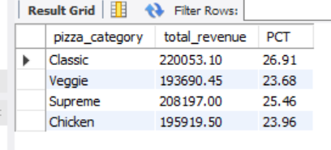
Output:

E. % of Sales by Pizza Size
SELECT pizza_size, CAST(SUM(total_price) AS DECIMAL(10,2)) as total_revenue,
CAST(SUM(total_price) * 100 / (SELECT SUM(total_price) from pizza_sales) AS DECIMAL(10,2)) AS PCT
FROM pizza_sales
GROUP BY pizza_size
ORDER BY pizza_size;

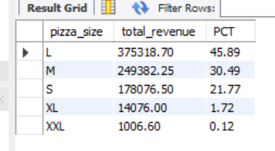
Output:

F. Total Pizzas Sold by Pizza Category
SELECT pizza_category, SUM(quantity) as Total_Quantity_Sold
FROM pizza_sales
WHERE MONTH(order_date) = 2
GROUP BY pizza_category
ORDER BY Total_Quantity_Sold DESC;

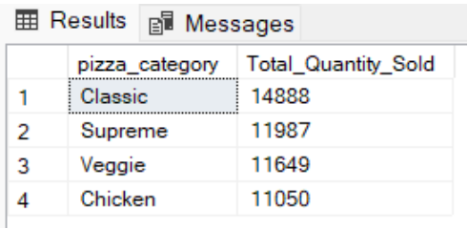
Output:

G. Top 5 Best Sellers by Total Pizzas Sold
SELECT pizza_name, SUM(quantity) AS Total_Pizza_Sold
FROM pizza_sales
GROUP BY pizza_name
ORDER BY Total_Pizza_Sold DESC
LIMIT 5;

Output:
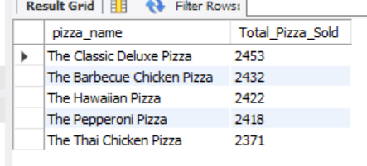

H. Bottom 5 Best Sellers by Total Pizzas Sold
SELECT pizza_name, SUM(quantity) AS Total_Pizza_Sold
FROM pizza_sales
GROUP BY pizza_name
ORDER BY Total_Pizza_Sold ASC
LIMIT 5;

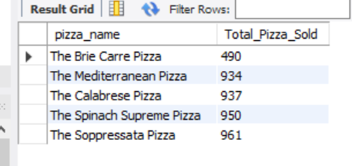
Output:

